**F20RO/F21RO Intelligent Robotics**

**Coursework Tutorial**

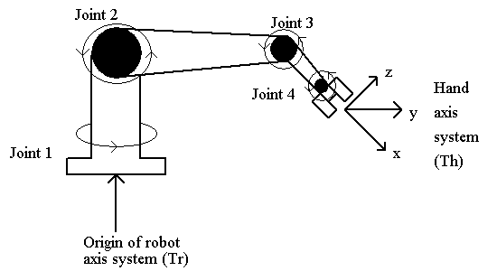

**TCP Orientation, α**

The Tool Centre Point orientation specified by your user is an absolute one and should be provided in the axis system of the robot or workplace. It is NOT the joint 4 (wrist) angle, *θ4*. It is a combination of the shoulder, elbow and wrist angles all working together.

Recall the Th matrix which specifies the location and orientation of the hand with respect to the robot co-ordinate system. We can obtain the *px, py, pz* column of this matrix directly from the user (possibly with some minor mapping operations). The 3*3 orientation part of the Th matrix must be determined from the user-specified orientation (absolute pitch). This will provide us with the *ax, ay, az* values we need for the inverse kinematic equations. Note that you CANNOT use the forward kinematic equations to derive these values - you will run around in circles if you try!

If we concentrate on the Th transformation from the robot orientation to the hand orientation we see that it must be composed of a joint 1 rotation, *θ1*, about the *z* axis followed by the user-specified orientation, α, about the *y* axis. Constructing the product matrix and equating terms we obtain -

**ax = cos(*θ1*) . sin(α)**

**ay = sin(*θ1*) . sin(α)**

**az = cos(α)**

Alternatively, we can note that the inverse kinematic equations don’t use the *ax, ay, az* values directly; they are used to determine *θ2 + θ3 + θ4* and it is this sum, *θ234*, which is used in the equations. Now, the user-specified angle must equal *90º minus this sum* in a robot with our geometry so we can take a short cut and simply substitute 90º minus the user’s angle wherever the sum is needed. Alternatively, we can let a pitch of 0º mean horizontally to the right, instead of straight up, and then *θ234* = α.

We can check this out by substituting the *ax, ay, az* values into the equation for *θ234*. We get -

***θ234* = arctan2{az, ax.cos(*θ1*) + ay.sin(*θ1*)}**

**= arctan2{cos(α), sin(α).[cos2(*θ1*) + sin2(*θ1*)]}**

**= arctan2{cos(α), sin(α)}**

**= arctan{tan(90 - α)}**

**= 90 - α if α=0º means straight up**

**or α if α=0º means horizontally to the right**